WAN Assignment
1. Comparison of WAN Connections
WAN Connection Type | Speed | Cost | Typical Use Cases
Leased Line | 10 Mbps – 10 Gbps+ | High | Large enterprises, banks, data centers, corporate offices requiring dedicated bandwidth
DSL (Digital Subscriber Line) | 1 Mbps – 100 Mbps | Low | Home internet users, small businesses, remote workers
MPLS (Multiprotocol Label Switching) | 1 Mbps – 10 Gbps+ | Medium to High | Enterprise branch connectivity, VPNs, voice and video communications
1. Leased Line
A leased line is a dedicated internet connection provided exclusively to one customer. It offers reliable, high-speed connectivity with guaranteed bandwidth and is commonly used by businesses that require constant network availability.
2. DSL (Digital Subscriber Line)
DSL uses existing telephone lines to provide internet access. It is less expensive than a leased line and is widely used in homes and small businesses. The speed may vary depending on the distance from the service provider.
3. MPLS (Multiprotocol Label Switching)
MPLS is a networking technology that efficiently routes data between different locations. It provides secure, reliable, and high-performance communication between company branches and is commonly used by large organizations.

2. CSU/DSU Connection Diagram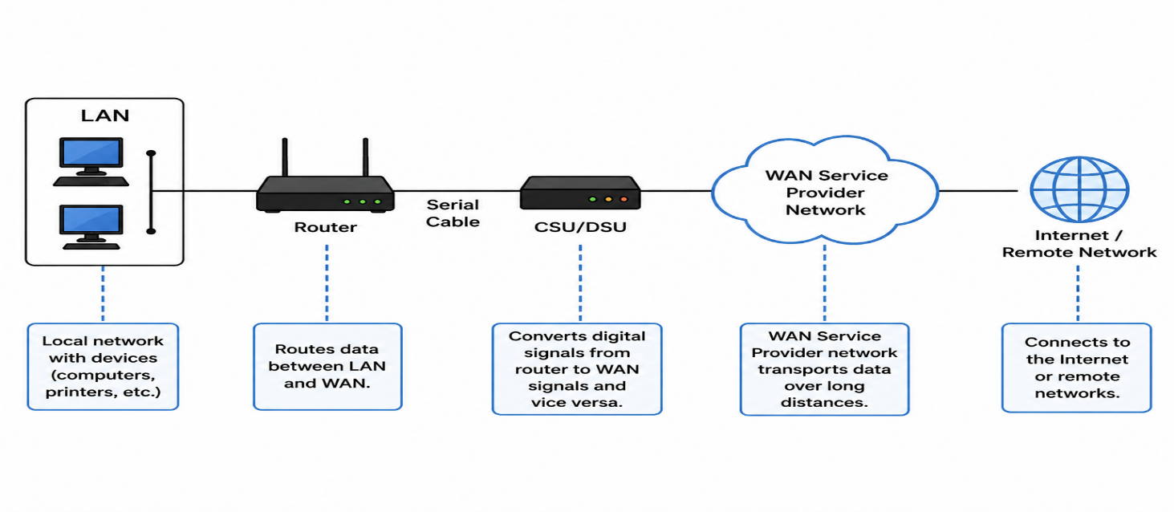

1. Router
A router connects the local network (LAN) to external networks. It determines the best path for data packets and forwards them between the organization's network and the WAN. The router is responsible for routing traffic to different destinations.
2. CSU/DSU (Channel Service Unit/Data Service Unit)
The CSU/DSU acts as an interface between the router and the WAN service provider's communication line. It converts the router's digital signals into a format suitable for transmission over the WAN circuit and converts incoming WAN signals back into a format the router can understand. It also performs signal conditioning, error detection, and line monitoring.
3. WAN Service Provider Network
The WAN service provider network is the infrastructure owned by telecom companies that connects geographically distant locations. It carries data between different cities, countries, or branch offices using technologies such as leased lines, MPLS, or fiber-optic networks.
How the Connection Works
- A computer on the LAN sends data to the router.
- The router determines where the data should be sent.
- The router forwards the data to the CSU/DSU through a serial connection.
- The CSU/DSU converts the data into a WAN-compatible signal.
- The WAN service provider transports the data across its network.
- The data reaches the destination network or the Internet.

3. Real-World Applications Using WAN
1. WhatsApp
WhatsApp relies on WAN to connect millions of users across the world through the internet. When a user sends a message, photo, video, or makes a voice/video call, the data travels through WAN to WhatsApp's servers and then to the recipient. WAN allows real-time communication between people located in different cities, states, or countries.
How WAN helps:
- Enables instant messaging worldwide.
- Supports voice and video calls over long distances.
- Allows sharing of photos, videos, and documents in real time.

2. IRCTC Rail Connect
IRCTC uses WAN to connect passengers with centralized railway databases and booking servers. When users search for trains, check seat availability, book tickets, or make payments, their requests are transmitted through WAN to IRCTC's data centers and the results are sent back instantly.
How WAN helps:
- Provides access to railway services from anywhere in India.
- Enables online ticket booking and cancellation.
- Allows real-time train status and seat availability checks.
- Supports secure online payment transactions.

3. Zomato
Zomato depends on WAN to connect customers, restaurants, delivery partners, and company servers. When a customer places an order, WAN transfers the order details to the restaurant and delivery partner. It also enables live order tracking and updates throughout the delivery process.

4. WAN Aggregator Device Research
Cisco ASR 1006-X
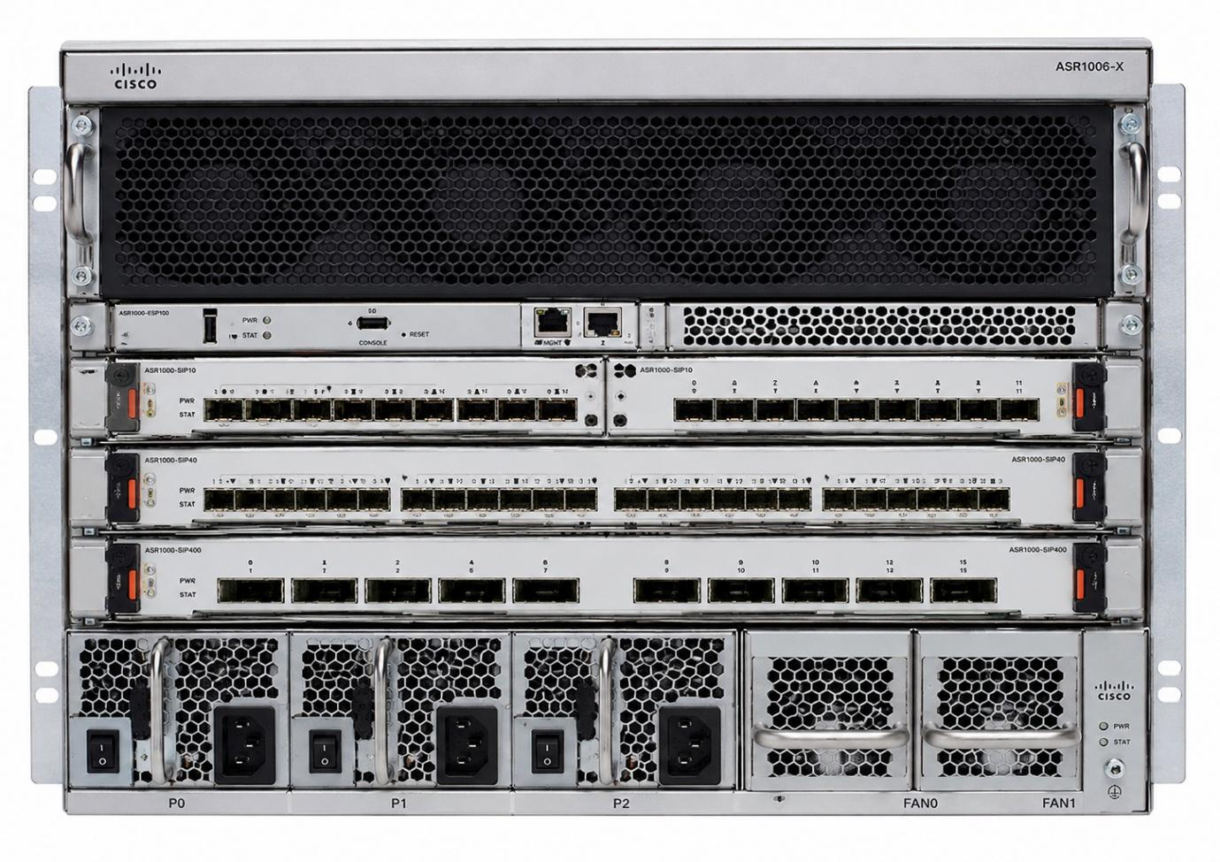

Image / Datasheet Link:
- Official Cisco Datasheet: Cisco ASR 1000 Series Datasheet
- Product page with image: Cisco ASR1001-X Router Image and Specifications
Device Description
The Cisco ASR 1001-X is an enterprise-grade WAN aggregation router. It is designed to aggregate multiple WAN connections and network services, providing secure and high-speed connectivity between branch offices, data centers, cloud services, and the Internet.
Two Key Features
- High WAN Throughput
  - The router can aggregate multiple WAN connections and supports throughput from 2.5 Gbps up to 20 Gbps (depending on licensing and configuration). This makes it suitable for large enterprise networks.
- Integrated Security and SD-WAN Support
  - It includes built-in encryption, traffic management, application visibility, and support for SD-WAN, helping organizations securely connect branch offices and cloud applications.

